Telnet NDN: A Comparison of Named Data Networking and TCP/IP

Cody Henderson, Pawan Subedi, Matthew York
Department of Computer Science
The University of Alabama
Tuscaloosa, AL
cthenderson@crimson.ua.edu, psubedi@crimson.ua.edu, matt.york@ua.edu
Xiaoyan Hong
Department of Computer Science
The University of Alabama
Tuscaloosa, AL
hxy@cs.ua.edu

Abstract— Proposed is adaptation of the telnet application found in the inetutils library for Named Data Networking. We demonstrate a drop-in replacement for the traditional socket-based networking with minimal intrusion to the telnet application itself. In addition, a comparison with traditional TCP/IP networking shows {awaiting testing}
Index Terms—Named Data Networking, Telnet, TCP/IP

Introduction
NDN stands for Named Data Networking, a project to redefine fundamental network architecture to meet the networking goals of the 21st century. Named data replaces traditional IP-based routing with a content-centric network model where each piece of information resides at a unique name[cite needed]. A content-centric model of information exchange adds greater opportunities for in-network storage (leading to bandwidth reduction) and wide area distribution while eliminating the need for a dedicated transport layer.
NDN is a pull based network. This means that the communication between any pair of devices is initiated by a request for data from one of the devices. Further, NDN doesn’t have server-client architecture: the request for the data is quenched by any device in the network that has it. This networking paradigm is useful in some of the application scenarios, but for others, direct communication between two fixed devices might be needed. Over the years, it has been shown that many traditional IP-based, end-to-end Internet tools or applications can be supported by NDN. Examples include audio/video conferencing [4,5], chat rooms [14], file sharing [15], and building control [9]. One application type that has not been addressed is remote terminal access, which similarly relies on dependable, point-to-point communication.
NDN holds particular promise in the Internet of Things (IOT) ecosystem due to the unique problems in the domain such as resource constraints and packet volume. Others have already begun work on future IOT/NDN architectures and methods [17,18,19,20]. Many devices, however, do not have physical user-interface I/O (i.e. keyboard, mouse, external buttons). Configuration changes with these devices require logging into them remotely, which presupposes network access to other computers. With NDN architecture, such remote terminal access is not directly possible due to its pull-based network model, particularly with familiar tools. This project attempts to reverse-engineer a robust remote client administration tool, telnet, and its server component, telnetd, to utilize NDN protocols instead of standard TCP/IP.

Background and Motivation
Inetutils is the foundational library for countless application around the world. One of the applications bundled in the inetutils library is telnet, a suite of programs for remote command of a terminal. Telnet is a worthy candidate for adaptation to Named Data Networking protocols due to its simplicity and lack of orthogonal requirements (security, etc). Below, in Figure 1, is an abstract breakdown of the telnet system showing the client and server applications, telnet and telnetd respectively, running on a given network.

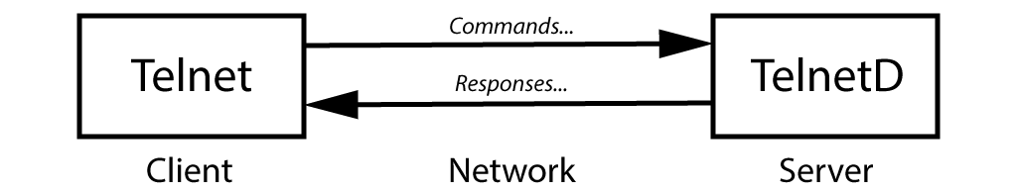

Fig. 1. The telnet system abstracted into parts and procedures

We propose a minimally-invasive replacement of socket method calls in inetutils with no disturbance to dependent applications. Furthermore, these socket replacement calls will be implemented in telnet as a model for named data networking in other bundled applications such as ftp. In addition, it will provide a useful metric for comparing named data viability versus traditional TCP/IP networking given that all non-networking application operations and constraints are the same.
One simple example where remote terminal access is required could be the configuration of RSU and OBU devices in vehicular communication. Most of the RSUs and OBUs run Linux system and are configured for sending and receiving different types of vehicular messages by running the respective applications in them through remote terminal access. In the IP-world, telnet and SSH are two of the majorly used applications for remote terminal access. Telnet is simpler but lacks security as it sends out the characters in plain text. Thus, in the present times, SSH is largely used instead of telnet. Security in SSH is achieved by securing the communication channel established between the two communicating parties. In NDN world, each data being sent out is secured within itself thus omits the requirement for securing the channel. Thus, NDN can achieve the security requirement even if it is using Telnet-like communication system. This work, hence, extends the telnet application into NDN paradigm. Similarly, there are so many applications built on top of these remote terminal access applications. Thus, transferring these applications into newer NDN architecture would be highly supported by the development of this work.

Architecture
There were a few major architectural goals in designing a named data version of the telnet system. First, the system should be built in the least invasive manner as possible. As telnet is a well-established application (over 30 years old), runtime stability was likely to decrease the more we changed the core application code. Second, the system should be extensible to other applications. There are other tools in the inetutils library in which telnet resides which could benefit from the same treatment. Therefore, finding a solution which can easily work for other applications increases the likelihood of retrofitting work by others in the future. Lastly, the system should maintain a respectable operating performance relative to the TCP version. This ultimately led us to two operational models which are discussed below.

A. Storing and Retrieving NDN State Variables
In traditional Unix TCP applications, file descriptors are used to refer to a socket held by an application. These file descriptors are integer-sized values. When designing our NDN socket replacement library, we needed to develop a method that would allow us to reuse these integer-sized references in the application's source code to refer to our own NDN state variables.
To achieve this, we use a temporary file to store the memory address of the NDN state variables. This temporary file is also referenced with a file descriptor, so it can be passed around the targeted application without substantial modifications. Every time one of the replacement socket functions is called, the ndn-socket library reads the temporary file from the file descriptor and creates a pointer to the existing NDN state variables in memory.

B. Direct Model
The Direct Model explores retrofitting options in which no telnet application code was changed. Our first attempt utilized C header includes to swap out the socket library used by the application with our own while leaving the method signatures intact. The goal of the direct model approach was to solve the retrofitting problem at compile time only.
There were significant problems with this approach. First, telnetd, the server portion of the application suite, utilized a built in linux service to manage multiple connections. It did not directly manage sockets and connections, meaning client requests would never propagate to our library. Secondly, the top level socket methods were not the only methods utilized by the applications. ndnsocket(), ndnbind(), ndnlisten(), ndnaccept() and ndnconnect() were all used as replacements for their non “ndn” prefixed counterparts to set up the initial connection. We found additional calls relating to the network socket in telnetd that were not a part of the sys/socket.h header.
In addition, the send and receive and file descriptor calls all required replacement. Commands such as read and write were nearly identical to the send() and recv() and required little effort to implement. Other functions, such as select and its related FD_ISSET were more difficult to implement. The total breadth of socket references proved too numerous to conform to our architectural goal of non-invasiveness, particularly since NDN is structured in a fundamentally different way. Figure 2 below shows the program path for the Direct Model, including modified calls.

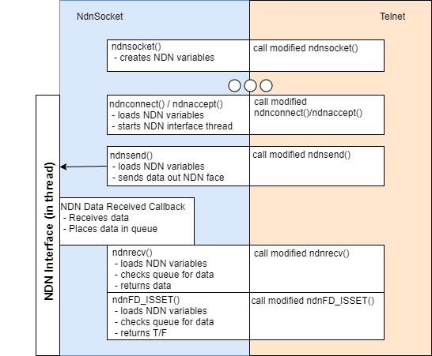

Fig. 2. Program paths for the Direct Model

C. Proxy Model
The Proxy Model, by contrast, only edits existing application code as it relates to the creating an NDN connection. Beginning with a client’s request to connect, the proxy model takes the NDN name from the user, and then reroutes (swaps) it with a local server address which is controlled by a new NDN module in the app. This local server acts as a kind of proxy for the client’s connection to the server. Telnet then performs the connection request as normal to the local server, but in the background the new NDN module makes an interest request to the true destination over NDN. When it responds, the contents are sent back from the NDN module to the telnet application. The same process occurs on the server side for inbound and outbound network requests. It is important to note that the Proxy Model, like the direct model, also required that the telnetd dependence on managed linux networking be transitioned to a custom solution. For the proxy model, this was implemented as a single socket. Support for multiple socket connections is left for future research as it is unnecessary to test throughput and responsiveness.
The main disadvantage of the proxy model is the added “hops” through the proxy NDN modules. We test the delays of these relative to the original TCP application in section V. There are, however, a number of architectural advantages. First, very little of the original application code is changed. The name is swapped, but then almost all other changes are additions, not mutations of existing code like in the Direct Model. In addition, the proxy model can be easily integrated into other applications as the aforementioned code additions amount to a "dumb proxy" with no concern for the application using it. Its job is simply to receive incoming socket data and forward it on via NDN. Therefore, the final implementation was completed using the proxy model. The program path for the Proxy Model is rendered below in Figure 3.

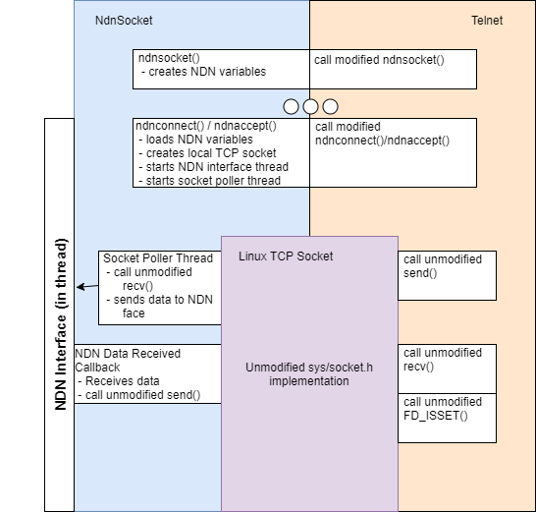

Fig. 3. Program paths for the Proxy Model

Telnet NDN Implementation
The standard inetutils library was forked from its mirrored location on GitHub for its adaptation to NDN. In addition, a separate repository houses C++ classes built for NDN web calls which mimic the underlying socket connections inside applications such as telnet. Other applications in the inetutils library such as ftp remained unchanged, but their use of socket connections was considered to aid in creating a more generally useful NDN adaptation for telnet.
As discussed in III, an intermediate goal was to ensure that the interfaces to the NDN web calls were similar to the original ones. Besides decoupling the linux service in telnetd, only method signatures and include statements were changed. The long term goal is for the interfaces to be the exact same so that using TCP networking or NDN networking will be a matter of package inclusion (a benefit of the straightforward inclusion style of C/C++). In the short term, socket creation calls were prefixed with "ndn" for ease of development and debugging. These method name changes are reflected in all telnet application files that require socket connections.
The telnet system works as a team of two app binaries, telnet and telnetd, with the former being the client and the latter being the server. The client negotiates a connection to the server and issues commands to the server to which it attempts to comply. Both telnet and telnetd rely on socket connection calls, with the client connecting directly to TCP sockets and the server using inetd linux daemon to handle incoming connection requests. The client networking logic only required method signature changes at the application level to accept NDN connections. NDN endpoints were simply used instead of DNS. The telnetd server network configuration was replaced wholesale with a socket implementation so that the NDN networking adaptations would work similarly to telnet. As noted in III.C, online a single socket was used, leaving the multi-socket scenario for future work.
Our NDN socket replacement library, ndn-socket, is written in C++. However, since the function signatures emulate those found in sys/socket.h, the new methods are compatible and can be linked with C application code. The ndn-socket library is able to handle two-way communication, so to help implement the required behavior using code derived from the Named Data Networking project page [16]. The original code created a two-way tunnel to act as a VPN for traditional IP traffic in which both nodes of the tunnel send interest packets to a NDN name prefix that refers to the opposite node. When the opposite node has data to send, it generates a data packet to fulfill one of the outstanding interests.
Figure 4 below illustrates how a socket connection is started. The socket command allocates internal variables that manage the NDN state. The bind() command saves the server's NDN name prefix. The listen() command creates an NDN interest packet filter that listens for any interests that are pointed to the server. Any incoming interests are placed in a queue. The accept() commands picks the first interest from the listen queue and responds to it with the expected tunnel NDN name. The original bind() and connect() functions accepted a struct that held IP specific information, such as IP address and port number. These were modified to pass in a string which contains an NDN prefix. At the moment, the prefixes are hardcoded. More modifications would be necessary to allow a prefix to be passed in as a command line argument to these programs or referenced as an environment variable.
At this point, the server is ready to communicate. When the client calls the connect command, an interest is sent to the NDN namespace that was passed into the connect command.

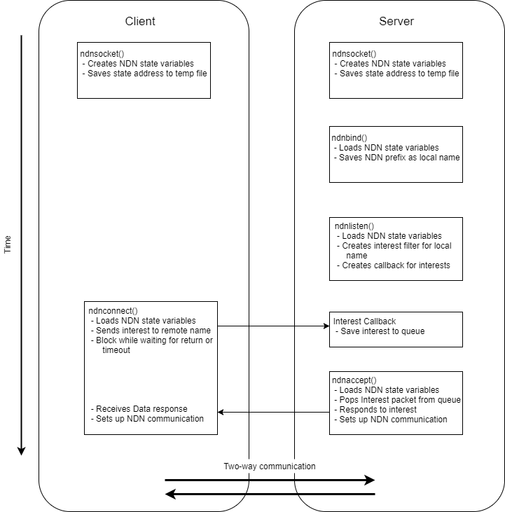

Fig. 4. Creation of an NDN socket between telnet client and server

The client's NDN prefix is also attached to the interest. When the server responds to that interest with a data packet, the client extracts the server's NDN name from the data packet and the two-way tunnel is started. The full list of commands is listed below in Table 1.

Socket to NDN Command Transformations
Socket Command | NDN Command
Bind | Save NDN Name
Listen | Queue Interest Packet
Accept | Get Interest Packet
Connect | Send Interest

Table 1. Table showing the transformation of traditional socket commands to NDN commands

Experimental Analysis
The experiment described below is designed to stress-test network throughput and responsiveness for the original and NDN versions of telnet. The goal is to understand the performance of the NDN telnet implementation relative to the TCP/IP version and determine its viability in real-world scenarios.

A. Experimental Setup
Experiments were conducted using 2 Ubuntu MATE virtual machine instances running on a mid-2012 Macbook Pro with a 2.6 GHz i7 processor and 16 GB of RAM. These instances were managed using the virtual box VM manager. Each instance was given 4 CPU cores and 2GB RAM. The instances were configured to work with a bridged connection on a single-router setup.

B. Experimental Procedure
Each instance was equipped with a named data forwarder (NFD) which could process inbound and outbound named data requests. Instance 1 was equipped with the telnet client while
instance 2 ran the telnet server, telnetd. The NDN and original applications were not run concurrently through testing. A Wireshark filter was used to determine throughput and responsiveness for both versions of the telnet system.
To test throughput and responsiveness, we used the worms application from the BSD Games library. Worms is a command line application which animates strings of text “worms” on screen. The program takes in a number of arguments, listed below in table 2, which were used as test variables for the Telnet comparisons.

Terminal Arguments for the Worms App
Command | Type | Description
-f | Boolean | Makes a “field” for the worms to eat
-t | Boolean | Makes each worm leave a trail
-d | Number | Specifies a delay in ms
-l | Number | Specifies the length for each worm
-n | Number | Specifies the number of worms

Table 2. Listing of all command line arguments for the worms application. These arguments were used as test variables for the NDN experimental trials.

C. Experimental Results
Experimental analysis was conducted with Wireshark through the Wireshark NDN plugin. This will allow us to analyze network capacity, overhead, etc. relative to the original telnet application. In order to be able to observe packet flow, two Named Data Forwarder instances (or NFDs) are required. Otherwise, the traffic stays inside of the single NFD routing mechanisms and goes undetected by other tools.
Experiment 1 tested throughput on a local network using the worms app. For this experiment, the number of worms n was locked to 1 as varying the delay d was satisfactory to achieve network saturation at d=0. The throughput results are listed below in Table 3.

Throughput in KB/s for Varying Delay in Worms
Network/d | 0 | 1 | 3 | 5 | 10 | 20
NDN | 552.1 | 167.1 | 59.3 | 38.4 | 22.4 | 12.8
TCP / IP | 533.4 | 91 | 29.9 | 28.3 | 14.1 | 8.5

Table 3. Network throughput values for varying values of d in Worms
Experiment 2 used the linux network emulation tool netem to reveal relative performance under strained network conditions. For this experiment, the number of worms n was locked to 1 and the delay was locked to 0. On the client virtual machine netem was run to emulate packet loss from 0% to 60%, the latter of which rendered the terminal unresponsive. The results of experiment 2 are shown below in Table 4.

Throughput in KB/s for Varying netem Packet Loss
Network/loss | 0% | 20% | 40% | 60%
NDN
TCP / IP | 546.2 | 63.5 | 11.0 | 1.9

Table 4. Network throughput values for varying degrees of packet loss as emulated through the Linux tool netem

Discussion
Here we would like to discuss a number of topics which are orthogonal to this paper’s main goal of comparing NDN and TCP networking through the telnet system. From these topics can we see some unique advantages of the NDN networking architecture.

A. Security in telnet and telnetd
A telnet security solution should provide verification of a messages identity, confidentiality and integrity. Telnet is less utilized for secure task work due to its (optional) use of Symmetric Key Encryption, usually with the help of centralized Kerberos ticket and authorization servers. More popular tools for secure remote administration, such as SSH, utilize Asymmetric Key Encryption through the exchange of public keys and no reliance on additional key infrastructure.
Fortunately, NDN adopts a signing model in the protocol itself for the binding of a particular name with a particular piece of content. One may verify the identity and integrity of an NDN packet through a provided signature and digest of the non-signature portions of an NDN packet. This leaves confidentiality as the only major problem to solve. For Telnet, we envision taking advantage of NDN’s packet structure to allow telnet and telnetd to swap public keys during the initial interest phase. Then, we would like to use the swapped public keys to encrypt outbound packets before digesting them. The consumer would then decrypt the packets after verifying their authenticity, providing the final goal of confidentiality. The above process is similar to an SSL “handshake”, and would require a trusted third party or other means (perhaps network precedent) to validate the keys.

A. Key Generation and Access Control
Research is already underway to better understand access control policies and key generation procedures for the NDN network. Yu explained the advantages of namespacing and key localization available for NDN [11]. They describe how to secure a series of blogs with hierarchical access and signing ability schematized by the name of the blog content and the name of the individual signer. In this way, NDN already supports a hierarchy of users and single-membership groups.
Others, such as Hamdane, propose using Hierarchical Identity-Based Cryptography (HIBC) in order to solve the missing link between NDN name resolution and a publisher’s public key [10]. Perez et. al chronicled numerous attacks against NDN through the real-world example of Building Automation and Control Systems and noted that the lack of a key distribution standard severely limits NDN [13].

Conclusions & Future Work
{summarize what you made and how it compared here}
Currently, the telnet client is issuing commands to the telnetd server over NDN using the two-way tunnel implementation. Through various means of debugging, including Wireshark and telnetd's internal logger, we can confirm that data is successfully passed. The current implementation does work for the telnet/telnetd scenario, but we have a couple of ideas that may allow ndn-socket to be used across more applications more easily.
In addition to the two-way tunnel implementation, we would like to create an ndn-socket variation that uses the ChronoSync library. We would be able to compare different metrics to determine if ChronoSync is a better choice for this use case than the two-way tunnel implementation. At this point, we know we have modified telnet and telnetd applications that can use our current ndn-socket header. It should be quicker to create a ChronoSync version since we only have to modify ndn-socket.
Additionally, we would like to explore a general solution for managing the mapping from multiple socket-to-NDN connections in applications (like telnetd) which depend on Linux’s core networking services. For now, telnetd is hard coded to accept and manage only one connection at a time. Expanding Telnet NDN to manage multiple connections would provide a better platform for concurrency testing and additional research.

References

- Zhang, Lixia, et al. "Named data networking." ACM SIGCOMM Computer Communication Review 44.3 (2014): 66-73.
- Zhang, Lixia, et al. "Named data networking (ndn) project." Relatório Técnico NDN-0001, Xerox Palo Alto Research Center-PARC (2010).
- Zhu, Zhenkai, and Alexander Afanasyev. "Let's chronosync: Decentralized dataset state synchronization in named data networking." Network Protocols (ICNP), 2013 21st IEEE International Conference on. IEEE, 2013.
- Zhu, Zhenkai, et al. "ACT: audio conference tool over named data networking." Proceedings of the ACM SIGCOMM workshop on Information-centric networking. ACM, 2011.
- Gusev, Peter, and Jeff Burke. "NDN-RTC: Real-time videoconferencing over named data networking." Proceedings of the 2nd International Conference on Information-Centric Networking. ACM, 2015.
- Shang, Wentao, et al. "Named data networking of things." Internet-of-Things Design and Implementation (IoTDI), 2016 IEEE First International Conference on. IEEE, 2016.
- Burke, Jeff, et al. "Securing instrumented environments over content-centric networking: the case of lighting control and NDN." Computer Communications Workshops (INFOCOM WKSHPS), 2013 IEEE Conference on. IEEE, 2013.
- Chen, Tao, Kai Lei, and Kuai Xu. "An encryption and probability based access control model for named data networking." Performance Computing and Communications Conference (IPCCC), 2014 IEEE International. IEEE, 2014.
- Shang, Wentao, et al. "Securing building management systems using named data networking." IEEE Network 28.3 (2014): 50-56.
- Hamdane, Balkis, et al. "Named-data security scheme for named data networking." Network of the Future (NOF), 2012 Third International Conference on the. IEEE, 2012.
- Yu, Yingdi, et al. "Schematizing trust in named data networking." Proceedings of the 2nd International Conference on Information-Centric Networking. ACM, 2015.
- Afanasyev, Alexander, et al. "Content-based security for the web." Proceedings of the 2016 New Security Paradigms Workshop. ACM, 2016.
- Perez, Victor, et al. "Security evaluation of a control system using Named Data Networking." Network Protocols (ICNP), 2013 21st IEEE International Conference on. IEEE, 2013.
- Phanama, Yudi Andrean, Fransiskus Astha Ekadiyanto, and Riri Fitri Sari. "Serverless Mobile Multiuser Chat Application Based on ChronoSync for Named Data Networking." Transactions on Networks and Communications 4.4 (2016): 32.
- Zhu, Zhenkai, Alexander Afanasyev, and Lixia Zhang. "ChronoShare: a new perspective on effective collaborations in the future Internet." Poster, UCLA Tech Forum. 2013.
- “Tunnel Ethernet Traffic Over NDN.” Named Data Networking (NDN), 5 Sept. 2017, named-data.net/2017/09/05/tunnel-ethernet-traffic-ndn/.
- Amadeo, Marica, et al. "Named data networking for IoT: An architectural perspective." Networks and Communications (EuCNC), 2014 European Conference on. IEEE, 2014.
- Hail, Mohamed Ahmed, et al. "Caching in named data networking for the wireless internet of things." Recent Advances in Internet of Things (RIoT), 2015 International Conference on. IEEE, 2015.
- Amadeo, Marica, Claudia Campolo, and Antonella Molinaro. "Multi-source data retrieval in IoT via named data networking." Proceedings of the 1st international conference on Information-centric networking. ACM, 2014.
- Shang, Wentao, et al. "Named data networking of things." Internet-of-Things Design and Implementation (IoTDI), 2016 IEEE First International Conference on. IEEE, 2016.

